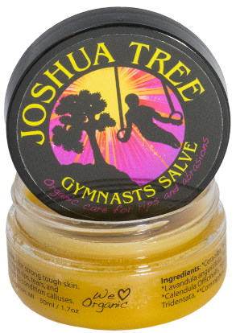
ORGANIC TREATMENT FOR RIPS AND ABRASIONS
JTree Gymnast salve is an organic, unscented skin-healer that is effective in treating rips, tears, and hot-hands. Created using a blend of essential oils, freshly extracted from the finest organic herbs, JTree Salve moisturizes and promotes healing without softening calluses that the body produces for protection.
DESIGNED TO HEAL ANY SKIN IRRITATION WITHOUT SOFTENING THE SKIN!
Why no softeners??? Because a healthy callus is your body's own natural protection, and it hurts when they get soft and peel!

FEATURES:
No added scents - The pleasant natural scent reveals how potent the salve is.
No skin softeners - Saves calluses.
Lush moisturizers - Fast relief from drying gym chalk.
Powerful healing - Make every training day count!
JOSHUA TREE GYMNASTS SALVE IS MADE WITH ORGANIC INGREDIENTS.
Beeswax: Creates desirable consistency and seals moisture in the skin.
Calendula: A wound healing herb that reduces inflammation of infected and irritated skin.
Comfrey: An herb that reduces pain and promotes healing by forming a protective surface over wounds.
Echinacea: An herb containing anti-bacterial and anti-inflammatory properties that aids in fighting infections and promotes healing.
Wildcrafted Chaparral: An herbal antibiotic containing antioxidants and antiseptic properties that decreases inflammation and wards off infection.
Myrrh Gum: A resin extracted from tree sap that contains strong disinfectant properties used to heal wounds.
Benzoin Gum: A resin extracted from the bark of trees that contains antiseptic properties to heal wounds and antioxidants that prevent infection.
Tea Tree Oil: Fights infections, acne and insect bites.
Lavender OIl: Heals wounds, burns, and prevents scarring.
Jojoba Oil: A liquid wax extracted from the seeds of jojoba trees that provides lasting moisture for skin.

TO CONDITION SKIN
1 - Wash with soap & water - clean skin heals faster!
2 - Groom calluses - Use a pumice stone to thin out thick spots.
3 - Apply JTree Salve to wrists and hands 2X a day!

RIPS AND TORN SKIN
1 - Clip or remove any dead torn skin.
2 - Wash with soap & water - clean skin heals faster!
3 - Liberally Apply JTree Salve at least 3X a day!

Joshua Tree Gymnast Salve Order form
Name: _____________________________
Number of jars: _______________ @$17 total:_____________________________

